Project Title

First student’s name (Team leader); Second student’s name; Last student’s name

Advisor: Lecturer’s name

Abstract: Only one paragraph for abstract (around 300 words). This section should summary the motivation for your project: what is the main methodology you used, and the results obtained, and global conclusion of project. Students don’t provide here any tables, citations, authorships. The abstract should paraphrase and summarize rather than quote from the paper.
Keywords: You should provide at least 4 keywords related to the project such as: Keyword 1; Keyword 2; Keyword 3; Keyword 4….
1. Introduction (1 – 2 pages)
This section should be divided into 3 or 4 paragraphs with references by using number, in brackets e.g [1], [2]... Using IEEE, MLA, or APA citation styles.
Students must present why to choose this topic, why it is important, and its application.
Students need to present the motivations for solving this topic, clearly discuss the input and output of project. 3 to 5 related papers should be cited in this section.
Some Remarks:
- Cite thoroughly but not excessively.
- Don't repeat the title.
2. Related Works (2-3 pages)
Students find recent published works (at least 4 papers) that have the similar approaches with projects on Google Scholar, Research Gate, Arxiv, or famous publishers (IEEE, Elsevier, Springer, ACM…). For each paper, students give a short review by introducing and analyzing their main approaches, data in experiment, obtained results, and the limitation (if applicable).
Some Remarks:
-Don’t paraphrase from papers, put your own interpretation and discuss the significance of each finding.
- Write in well-structured paragraphs
3. Data Preparation (1 - 2 pages)
You must present data relevant to the topic of the article as defined in the introduction. Describe the state-of-the-art of datasets in used for this topic with references. How many existing/public/private datasets you can access? Give a table for comparison (if applicable).
Students need to present how the dataset is built? How many classes (or samples). If this is your own dataset, explain the process how to collect this data.
Table 1: Example of review datasets (for face recognition task).
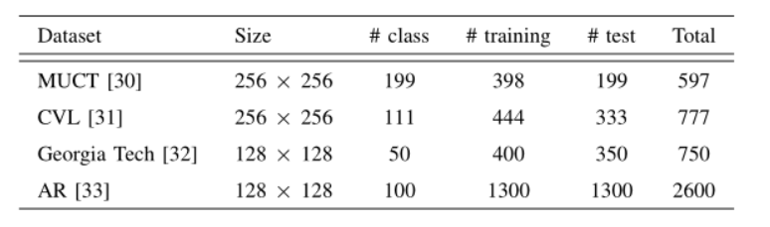
Illustrate several examples of your dataset with detailed captions. It can be some images, image cut from video, waveform of signal, time-series, some text phrases depending on your considered dataset.
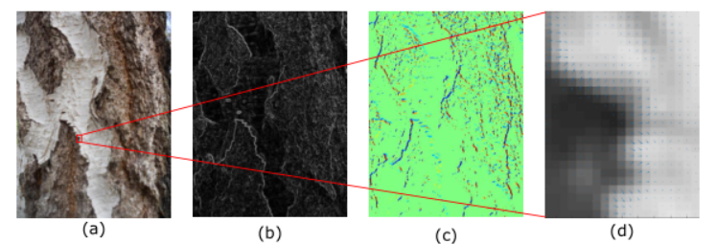
Figure 1: Example of images dataset (bark texture recognition).
If that is preprocessing data, like features extracted from descriptors, student need to explain and include a citation where and how to obtain?
The cross validation to decompose the training, validation test is needed to discuss.
4. Methods (2-3 pages)
Present the process from input to output by a figure (if applicable) and explain how each step works. The relevant mathematical notations and equations (using Microsoft Equation to type variables and formula) should be included and numbered.
Students need to write the methods that another student’s group can understand easily.
If this project has some contributions, you need to mention and emphasis those parts. For example, you propose some nee ideas to achieve better results or reduce the complexity of existing methods.
If there are many things to present, you can divide Section 4 into many subsections.
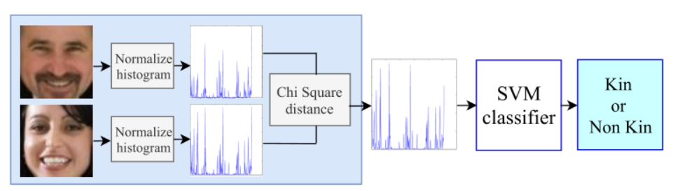
Figure 2: Example of the process (kinship verification).

Some Remarks:
Tables should also be numbered consecutively using Arabic numbers. They should be placed in the text soon after where they were referenced. Captions should be centered in the format “Table 1: The text caption …”. In the text, you should reference a table as such: For example, see Tab. 1.

5. Results and Discussion (2-3 pages)

You should present what parameters and value used to obtain the experimental results.
The specific metrics for evaluation are listed with equation, for examples:
- if you solve a classification/recognition, you need to present confusion matrix and related performance such as accuracy, F1, precision.
- for detection problem, you need to illustrate IoU, AP
- for image quality, using PSNR, SSIM metrics
- for key point or landmark detection, using OKS, PDJ
- report the mean with standard error or standard deviation from statistical analysis.

Students should present in detail how to compute the specific metrics. You can present the performance by using tables or plots for both quantitative and qualitative results. Include visualizations of results, heatmaps, examples of where your methods/algorithms failed or reach the limit. Try to explain and discuss why they failed or achieve the best results. You must discuss and mention all the figures/tables in your main text throughout this section. Your plots should include legends, axis labels, with good image resolution for printing (see an example in Figure 3 and 4). All tables and figures must be in order and number.

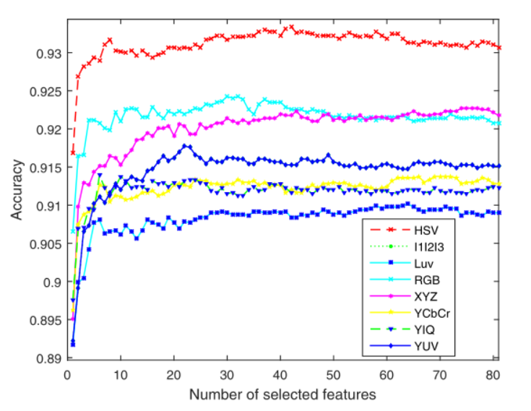
Figure 3. Example of performance (for classification task).

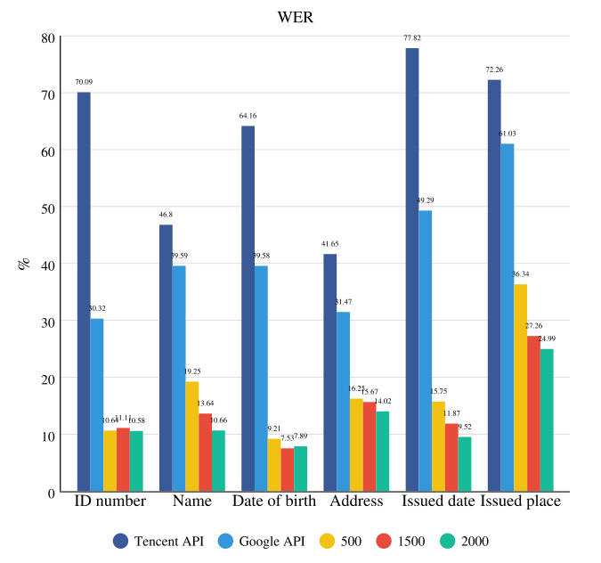
Figure 4. Example of performance (for text recognition task).

6. Conclusion and Perspectives (0.5 page)

Summarize your report in one or two paragraphs. Which methods or algorithms achieves the best performance? Why do you think that some algorithms worked better than others? Is there any limitation and drawback of your works? If you had more time and more computational resources, or more team members, what aspects you should propose and explore to improve the performance?
Some Remarks:
- Do not repeat results
- Do not include irrelevant conclusions, different from the topic.
Acknowledgement
The final report may include an acknowledgment section (if necessary).

References

This section should include citations for: (1) Any papers mentioned in the related work section. (2) Papers describing algorithms that you used which were not covered in class. (3) Code or libraries you downloaded and used. This includes libraries such as scikit-learn, Matlab toolboxes, Tensorflow, etc.
Note that the format for journals, books and other publications are different. Acceptable formats include MLA, APA, IEEE. References at the end should be arranged in the order in which they appear in the text.

- Hastomo, W., 2020. Gesture Recognition For Pencak Silat Tapak Suci Real-Time Animation. Jurnal Ilmu Komputer dan Informasi, 13(2), pp.77-87.
- Ijeh, A.C. and Masri, A.N.A., 2021. Using Gesture Recognition to Prevent Drowning. Crime Science and Digital Forensics: A Holistic View, p.20.
- Wattanakitrungroj, N., Pinpo, N. and Tongman, S., 2021, June. Sentiment Polarity Classification using Minimal Feature Vectors and Machine Learning Algorithms. In The 12th International Conference on Advances in Information Technology (pp. 1-8).
- Saleem, F., Ullah, Z., Fakieh, B. and Kateb, F., 2021. Intelligent Decision Support System for Predicting Student’s E-Learning Performance Using Ensemble Machine Learning. Mathematics, 9(17), p.2078.
- Kim, M.K., 2020. Comparison of Off-the-Shelf DCNN Models for Extracting Bark Feature and Tree Species Recognition Using Multi-layer Perceptron. Journal of Korea Multimedia Society, 23(9), pp.1155-1163.

Appendix A. Project Plan management
Here is an example of Project plan, you can modify and add relevant information according to your project.

Task Name | Priority | Owner | Start date | End date | Status | Issues
Find documents | High | Student A | …… | …… | In progress | ……
Review related papers | Medium | Student A | …… | ……
Review and analyze public dataset | Low | Student B | …… | …… |  | Not found appropriate dataset
Collect and label data | High | Student B | …… | …… | …… | ……
Evaluate potential method | Medium | Student B | …… | …… | …… | ……
Experiment | Low |  | …… | …… | …… | ……
Compare results | Medium | Student B | …… | …… | Finished | Bad performance
Writing appendix | Low | Student B | …… | …… | Pending | ……
Future works | High | …… | …… | …… | …… | ……

Appendix B. Source code & Data
Students put here link of source code and dataset (Google drive, One drive….)

